Missionaries and Cannibals Problem:
Aim:
To implement a Python program to solve the Missionaries and Cannibals problem using the Breadth First Search (BFS) algorithm in Artificial Intelligence.
Objective:
- Implement the Missionaries and Cannibals problem in Python.
- Use Breadth First Search (BFS) to find a valid solution.
- Ensure that missionaries are never outnumbered by cannibals on either river bank.
- Understand the application of state-space search in Artificial Intelligence.
Algorithm:
- Start the program.
- Initialize the start state as (3, 3, Left), where all three missionaries and three cannibals are on the left bank, and the boat is on the left side.
- Define the goal state as (0, 0, Right), where all missionaries and cannibals have safely crossed to the right bank.
- Create a queue and insert the start state into it.
- Create an empty set to keep track of the visited states.
- Remove the first state from the queue.
- Check whether the current state is the goal state.
- If yes, display the solution path and stop the program.
- If no, continue to the next step.
- Generate all possible valid boat moves:
- Two Missionaries (2M)
- Two Cannibals (2C)
- One Missionary and One Cannibal (1M,1C)
- One Missionary (1M)
- One Cannibal (1C)

- Validate each generated state by ensuring:
- The number of missionaries and cannibals remains between 0 and 3.
- Missionaries are never outnumbered by cannibals on either bank (unless there are no missionaries on that bank).
- The state has not been visited previously.
- Add each valid unvisited state to the queue and mark it as visited.
- Repeat Steps 6–10 until the goal state is reached or the queue becomes empty.
- If the queue becomes empty without reaching the goal state, display "No solution found."
- Stop the program.
Flow Chart:
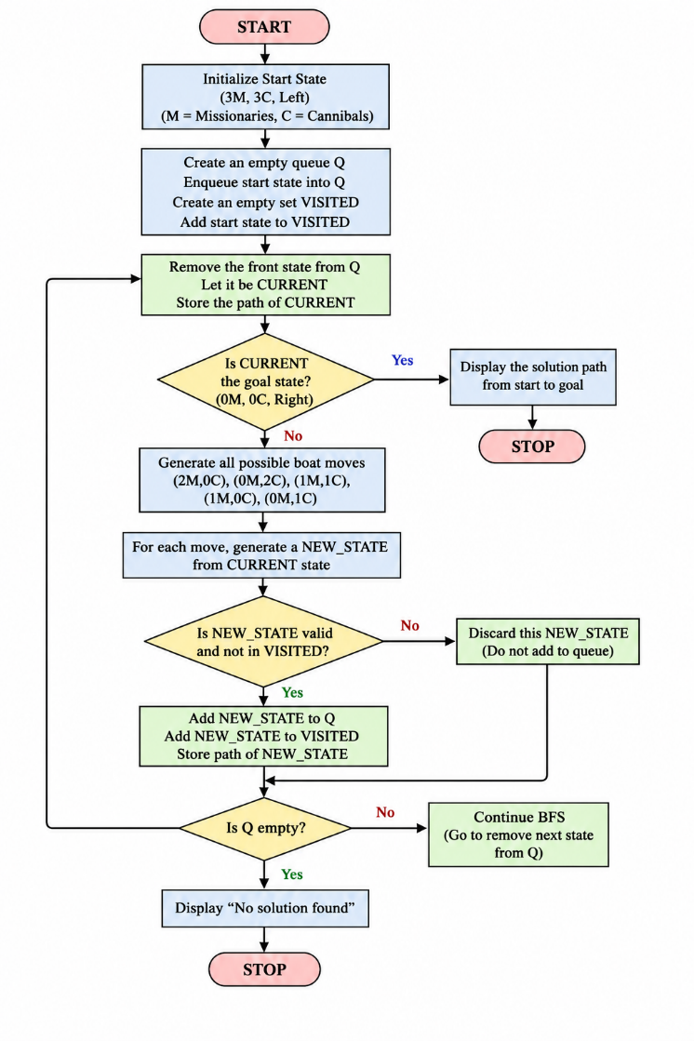

Python Code:
from collections import deque
# Possible boat moves (Missionaries, Cannibals)
moves = [(2,0), (0,2), (1,1), (1,0), (0,1)]
# Check if a state is valid
def is_valid(state):
M_left, C_left, boat = state
M_right = 3 - M_left
C_right = 3 - C_left
if M_left < 0 or C_left < 0 or M_left > 3 or C_left > 3:
return False
if M_left > 0 and M_left < C_left:
return False
if M_right > 0 and M_right < C_right:
return False
return True
# Generate next possible states
def get_next_states(state):
M_left, C_left, boat = state
next_states = []
if boat == 1: # Boat on left side
for m, c in moves:
new_state = (M_left - m, C_left - c, 0)
if is_valid(new_state):
next_states.append(new_state)
else: # Boat on right side
for m, c in moves:
new_state = (M_left + m, C_left + c, 1)
if is_valid(new_state):
next_states.append(new_state)
return next_states
# Breadth First Search
def bfs():
start = (3, 3, 1)
goal = (0, 0, 0)
queue = deque([[start]])
visited = set()
while queue:
path = queue.popleft()
state = path[-1]
if state == goal:
return path
if state not in visited:
visited.add(state)
for next_state in get_next_states(state):
new_path = list(path)
new_path.append(next_state)
queue.append(new_path)
return None
# Main Program
solution = bfs()
if solution:
print("Solution Path:\n")
for state in solution:
M_left, C_left, boat = state
side = "Left" if boat == 1 else "Right"
print(f"Missionaries Left: {M_left}, Cannibals Left: {C_left}, Boat: {side}")
else:
print("No solution found.")
Sample Output:
Solution Path:
Missionaries Left: 3, Cannibals Left: 3, Boat: Left
Missionaries Left: 3, Cannibals Left: 1, Boat: Right
Missionaries Left: 3, Cannibals Left: 2, Boat: Left
Missionaries Left: 3, Cannibals Left: 0, Boat: Right
Missionaries Left: 3, Cannibals Left: 1, Boat: Left
Missionaries Left: 1, Cannibals Left: 1, Boat: Right
Missionaries Left: 2, Cannibals Left: 2, Boat: Left
Missionaries Left: 0, Cannibals Left: 2, Boat: Right
Missionaries Left: 0, Cannibals Left: 3, Boat: Left
Missionaries Left: 0, Cannibals Left: 1, Boat: Right
Missionaries Left: 1, Cannibals Left: 1, Boat: Left
Missionaries Left: 0, Cannibals Left: 0, Boat: Right
Result:
